Multimedia Programming CA3 Report

Unity Game

Daniel O’Toole – N00145852

Introduction

For this ca we were tasked with making a game in the programme called unity. Unity is a game engine developed by Unity Technologies and is used by game developers to make games for PC, Consoles and Mobile Devices. Unity is used for both 3d and 2d games alike. For my game I decided to make a simple 3d maze type game. The aim of the game is to make your way through the level/maze and collect the circle objects while avoiding the enemy cubes. If you die you respawn from the start of the level. I also have a simple start and end screen.

Design

For the design of my game I kept it simple by make my character and enemies cubes as I like the simple UI look to games. I also decided to keep the colour scheme simple with a black and white scheme for the level and a red and green for the characters. I put the colour of the coins as yellow but that could change. I made the UI for coin counter in the top left corner very simple as well.

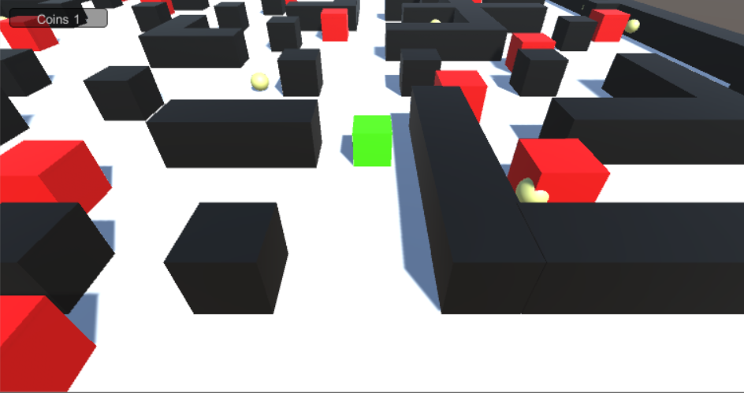

Implementation

To get an initial understanding of how the game engine of Unity works I followed a few tutorials related to my game. I then started off by making a basic floor, player cube, cube walls and then finally enemy cubes. I then added some materials to each of the objects to give them colours and better shape to them. I then started added code to the objects. I added simple code to make my player move. I also added code to make my enemy cubes move, they work by using ‘patrol points’ where they simple go from one point to the other point in an endless loop until the player collides with them. I then added coins and a goal and added code to both. I then added a simple main menu and an end screen.

Code   
For the code I will briefly talk about some parts of my code as there is a lot and this is aimed to be a short report.

Below is a screenshot of how the player cube moves. Unity has a lot of built-in functions already so it is just wise to use them here. The input.GetAxisRaw part basically gets the input from the up, down, left and right arrow keys. Then when I made my cube I added the rigidbody attribute straight away. This helps the player cube act normal under the laws of physics. Then it adds force with the input from the arrow keys to go in the right direction and ive already defined what my movespeed is in the object inspector.

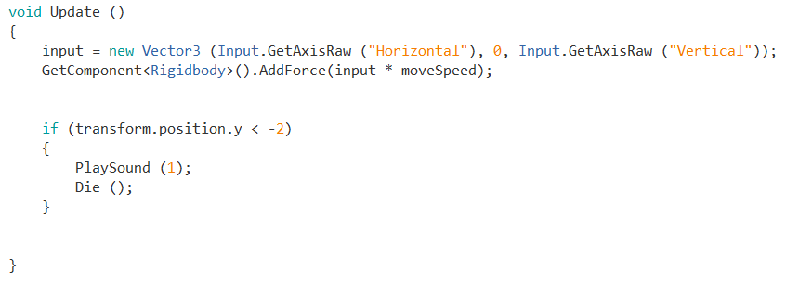

Below is another screen shot of my player code and this time it is some simple collision code. If the player object collides with any object with the enemy tag it will play the second in the sound arraylist ive already defined, the second sound is the player death and then it calls the method Die();. Ive already defined Die(); as what happens to the player cube when it dies. It creates particles ive made early on and changes the player cube’s position back to the start of the level, so it basically respawns the player at the start position of the level. If the player cube collides with the goal tag (end of level object) it plays level completion sound and load the next level, which is the end screen.

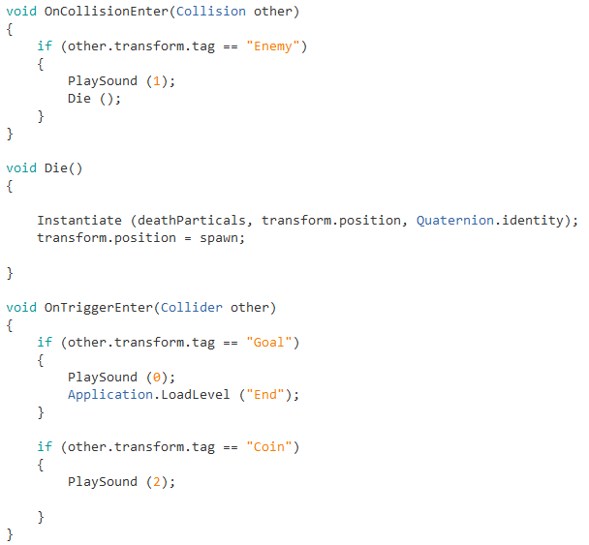

Below is another screen shot of the enemy cubes movement code. Basically there are these empty object points in the level where the cube moves toward them and when it reaches that point it goes to the next one and if that’s the last point in the list it moves towards the first point again, its an endless cycle of the enemy cubes constantly moving.

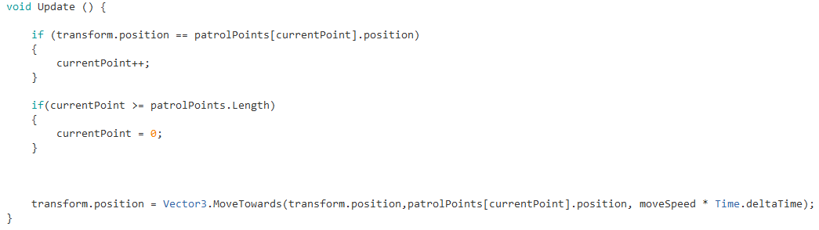

Conclusion

If I’m being honest I had a lot of fun messing around with the Unity game engine and enjoyed my time learning how the system works. In the future I definitely plan on learning more and more about unity and plan to develop and produce more games as it is my passion.